Inter-Vlan Routing

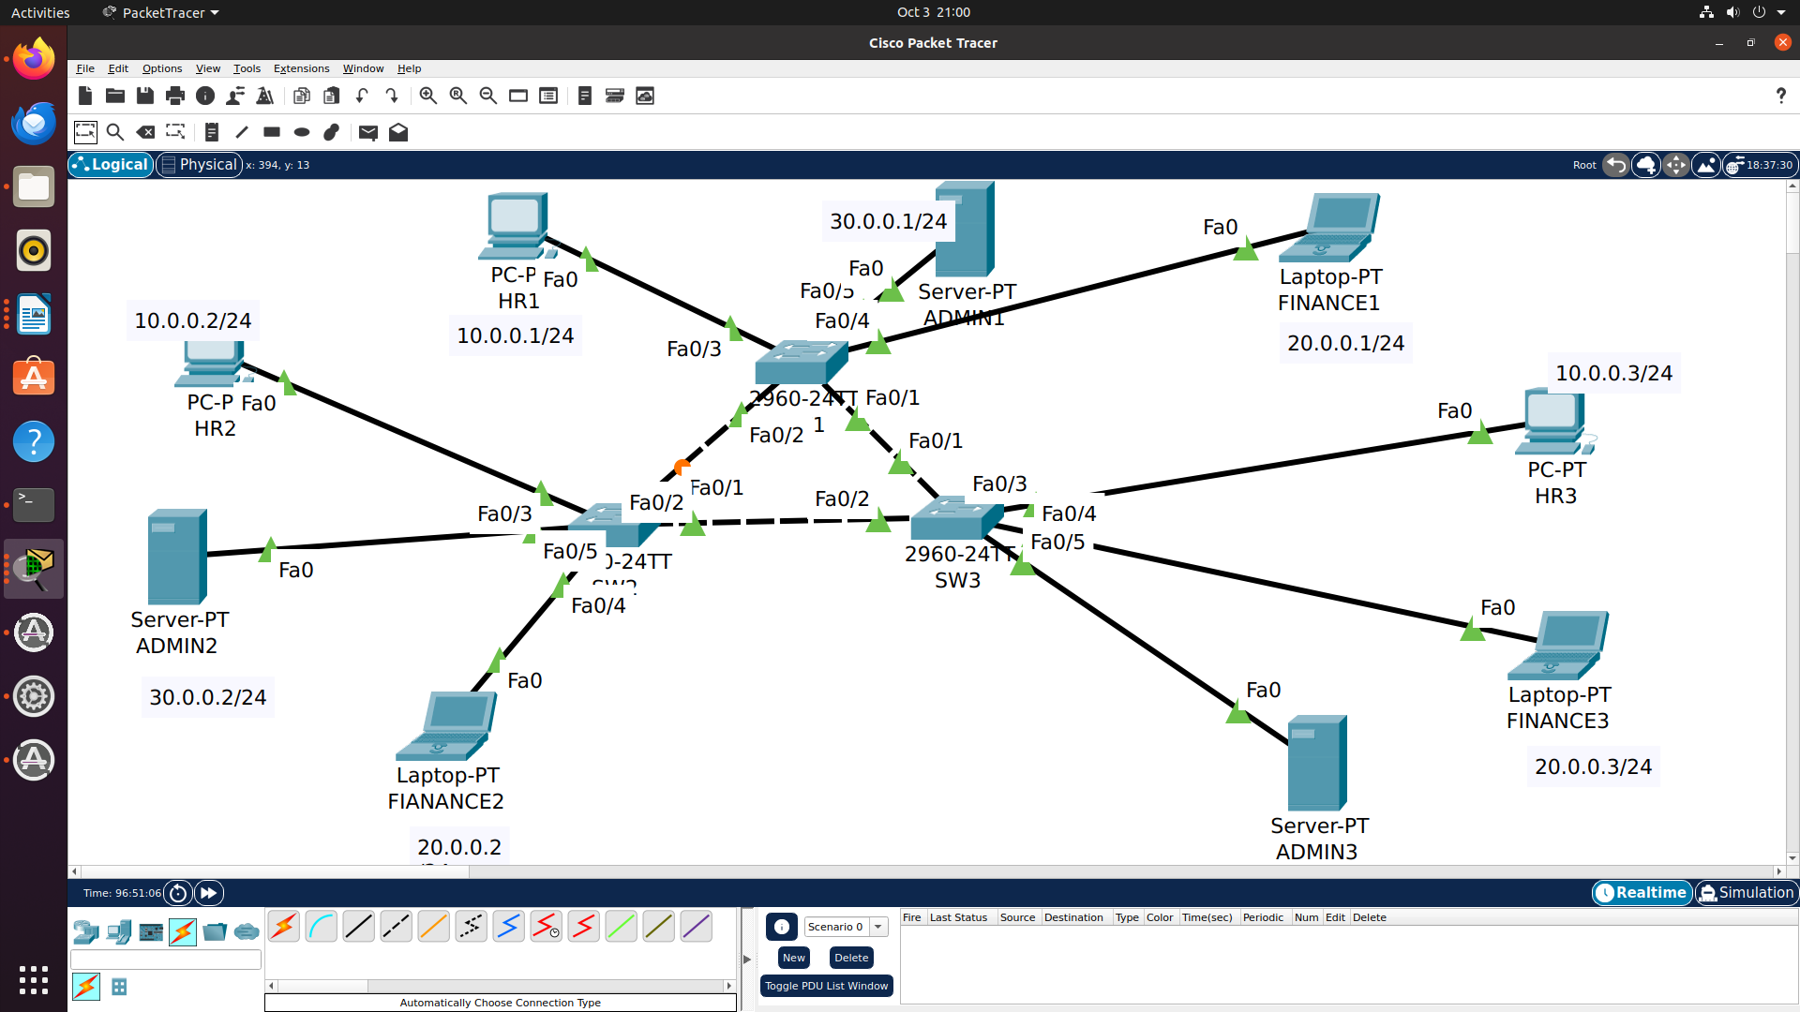

SW1(config)#vlan 10
SW1(config-vlan)#name hr
SW1(config-vlan)#vlan 20
SW1(config-vlan)#name finance
SW1(config-vlan)#vlan 30
SW1(config-vlan)#name admin

SW1(config)#int fastEthernet 0/3
SW1(config-if)#switchport access vlan 10
SW1(config-if)#switchport mode access

SW1(config)#int fastEthernet 0/4
SW1(config-if)#switchport access vlan 20
SW1(config-if)#switchport mode access

SW1(config)#int fastEthernet 0/5
SW1(config-if)#switchport access vlan 30
SW1(config-if)#switchport mode access

SW2(config)#vlan 10
SW2(config-vlan)#name hr
SW2(config-vlan)#vlan 20
SW2(config-vlan)#name finance
SW2(config-vlan)#vlan 30
SW2(config-vlan)#name admin

SW2(config)#int fastEthernet 0/3
SW2(config-if)#switchport access vlan 10
SW2(config-if)#switchport mode access

SW2(config)#int fastEthernet 0/4
SW2(config-if)#switchport access vlan 20
SW2(config-if)#switchport mode access

SW2(config)#int fastEthernet 0/5
SW2(config-if)#switchport access vlan 30
SW2(config-if)#switchport mode access

SW3(config)#vlan 10
SW3(config-vlan)#name hr
SW3(config-vlan)#vlan 20
SW3(config-vlan)#name finance
SW3(config-vlan)#vlan 30
SW3(config-vlan)#name admin

SW3(config)#int fastEthernet 0/3
SW3(config-if)#switchport access vlan 10
SW3(config-if)#switchport mode access

SW3(config)#int fastEthernet 0/4
SW3(config-if)#switchport access vlan 20
SW3(config-if)#switchport mode access

SW3(config)#int fastEthernet 0/5
SW3(config-if)#switchport access vlan 30
SW3(config-if)#switchport mode access

To configure Trunk mode for link connecting between switches

SW1(config)#interface fastEthernet 0/1
SW1(config-if)#switchport mode trunk

SW1(config)#interface fastEthernet 0/2
SW1(config-if)#switchport mode trunk

SW2(config)#interface fastEthernet 0/1
SW2(config-if)#switchport mode trunk

SW2(config)#interface fastEthernet 0/2
SW2(config-if)#switchport mode trunk

Switch 3 Trunk mode commands
SW3(config)#interface fastEthernet 0/1
SW3(config-if)#switchport mode trunk

SW3(config)#interface fastEthernet 0/2
SW3(config-if)#switchport mode trunk

R1(config)#interface fastEthernet 0/0.10
R1(config-subif)#encapsulation dot1Q 10
R1(config-subif)#ip address 10.0.0.254 255.255.255.0
R1(config-subif)#no shutdown

R1(config)#interface fastEthernet 0/0.20
R1(config-subif)#encapsulation dot1Q 20
R1(config-subif)#ip address 20.0.0.254 255.255.255.0
R1(config-subif)#no shutdown

R1(config)#interface fastEthernet 0/0.30
R1(config-subif)#encapsulation dot1Q 30
R1(config-subif)#ip address 30.0.0.254 255.255.255.0
R1(config-subif)#no shutdown

R1#sh ip int brief
Interface IP-Address OK? Method Status Protocol
FastEthernet0/0 unassigned YES unset administratively down down
FastEthernet0/0.10 10.0.0.254 YES manual administratively down down
FastEthernet0/0.20 20.0.0.254 YES manual administratively down down
FastEthernet0/0.30 30.0.0.254 YES manual administratively down down
FastEthernet0/1 unassigned YES unset administratively down down
Vlan1 unassigned YES unset administratively down down

R1(config)#interface fastEthernet 0/0
R1(config)#no shutdown

R1(config-if)#
%LINK-5-CHANGED: Interface FastEthernet0/0, changed state to up

%LINEPROTO-5-UPDOWN: Line protocol on Interface FastEthernet0/0, changed state to up

%LINK-5-CHANGED: Interface FastEthernet0/0.10, changed state to up

%LINEPROTO-5-UPDOWN: Line protocol on Interface FastEthernet0/0.10, changed state to up

%LINK-5-CHANGED: Interface FastEthernet0/0.20, changed state to up

%LINEPROTO-5-UPDOWN: Line protocol on Interface FastEthernet0/0.20, changed state to up

%LINK-5-CHANGED: Interface FastEthernet0/0.30, changed state to up

%LINEPROTO-5-UPDOWN: Line protocol on Interface FastEthernet0/0.30, changed state to up

Link from switch to router also enable trunk mode
SW1(config)#interface fastEthernet 0/6
SW1(config-if)#switchport mode trunk

